OOP Lab
- Write a Java program to create a class student with members, USN and names, include methods to accept and display student details. Create multiple student objects and display the results.
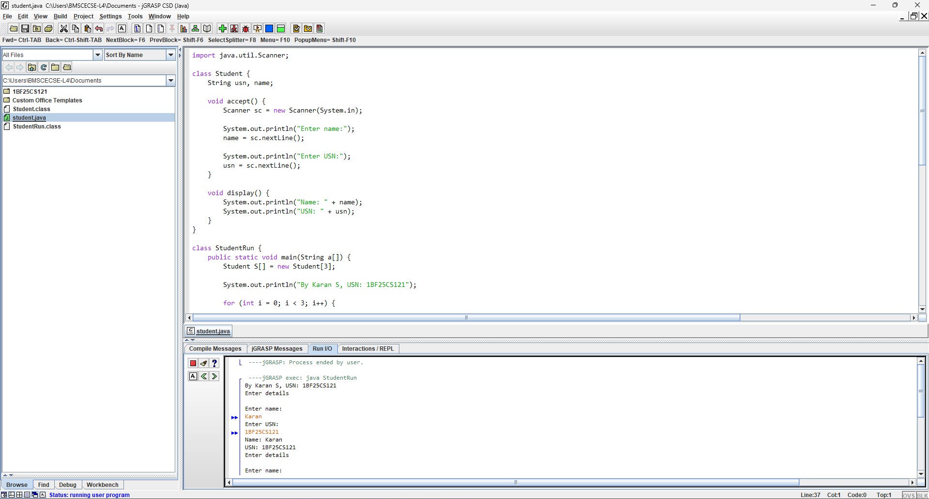
import java.util.Scanner;
class Student {
String usn, name;
void accept() {
Scanner sc = new Scanner(System.in);
System.out.println("Enter name:");
name = sc.nextLine();
System.out.println("Enter USN:");
usn = sc.nextLine();
}
void display() {
System.out.println("Name: " + name);
System.out.println("USN: " + usn);
}
}
class StudentRun {
public static void main(String a[]) {
Student S[] = new Student[3];
System.out.println("By Karan S, USN: 1BF25CS121");
for (int i = 0; i < 3; i++) {
System.out.println("Enter details\n");
S[i] = new Student();
S[i].accept();
S[i].display();
}
}
}

